The getting started video was immensely helpful both in the how-to and how-to-come-up-with-an-idea sense. I started from scratch using the lesson as a template. I am working solo but would be willing to team up with a classmate who is vegan or vegan-curious.

The concept is to have an array of whole food plant based and vegan ingredients to choose from that will be connected to a search box itself connected to an API that returns vegan-friendly/vegetarian-friendly dishes. In turn, the user can click on the returned recipe photos for recipe details. So far my client is both me and any other vegans who know what ingredients they already have in their kitchen and want to prepare dishes using them. To keep it simple, no amounts (teaspoons, milliliters, etc.) are required when an ingredient is entered or clicked. I'm not engineering a recipe site, but I am offering online recipe connectivity via ingredient entry. Unhealthy ingredients from a whole food plant based, vegan, low-oil perspective, like olive and canola oils, will not be included as ingredient choices, but recipes returned may include these ingredients unless filtering after-the-fact is feasible.

I used a $10/month subscription to a GitHub's Co-Pilot service to narrow down database connectivity options and was able to connect to the "spoonacular" API. The result is pictured below.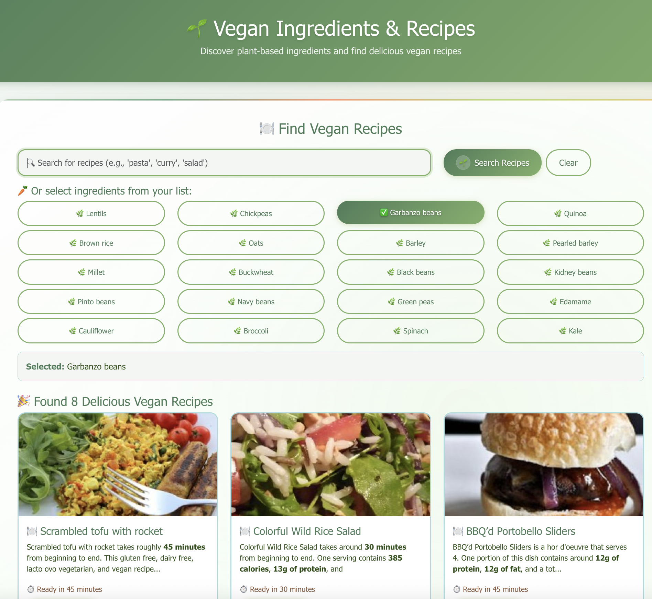

The Edamam recipe search API has fewer recipes and may be more appropriate for my/my target audience's needs. Their search API offers a vegan filter “(&health=vegan)” that could be automatically incorporated into searches.

Unfortunately the spoonacular API does return ovo-lacto vegetarian dishes which my target audience might be disaffected by, so I hope to be able to filter out such results by adding exclusions automatically (“and not ovo || lacto”). Alternatively I might be able to hide such results from being shown to the otherwise disappointed client.

I was also thinking of providing results from more than one API given how one API is too broad in its returns, and the more narrowly tailored Edamam API may not always result in a successful search. Alternatively a user could click on the preferred API, then search. That may be more realistic.

Other related APIs include TheMealDB API which offers a vegan category filter and is user-supported with an unlimited free tier. Recipe Puppy is free but requires manual vegan filtering.

APIs aside, I first want to focus more on making sure my buttons insert ingredients into the search bar, as I lack that functionality thus far. I used Copilot to help with bootstrap because I finished the Bootstrap Nucamp module several years ago and am a bit rusty. Besides, that is not the focus of this course, and I feel I am picking it back up by osmosis. So my page is attractive but currently lacks functionality other than the aforementioned API connectivity.

I want my client to be able to add and remove elements from the ingredients array I provide.

Using something like map would preserve the existing array but allow the client to have a custom array of his favorite foods. Perhaps the customer detests sea vegetables and would like to remove that whole category of plant based foods from his custom list.

Another feature of customer interest is a post-search filter eliminating non-vegan foods from search results.

I noticed that a recent ECMAScript revision adds functionality related to sets, and it might be useful to see whether additional functionality relating to removing or adding food categories could be incorporated by using methods relating to sets.

I also want to add a form to allow the user to enter his or her information as a condition precedent to using search. Check boxes could allow the user to opt in to receiving promotional materials. In the event the user did not allow this, ingredient searches on the recipe API could be limited to, say, ten.